Websphere Server Data Source Set Up

- Start Websphere Application Server
- Select Application Server in Console, Right click and run Administrative console.
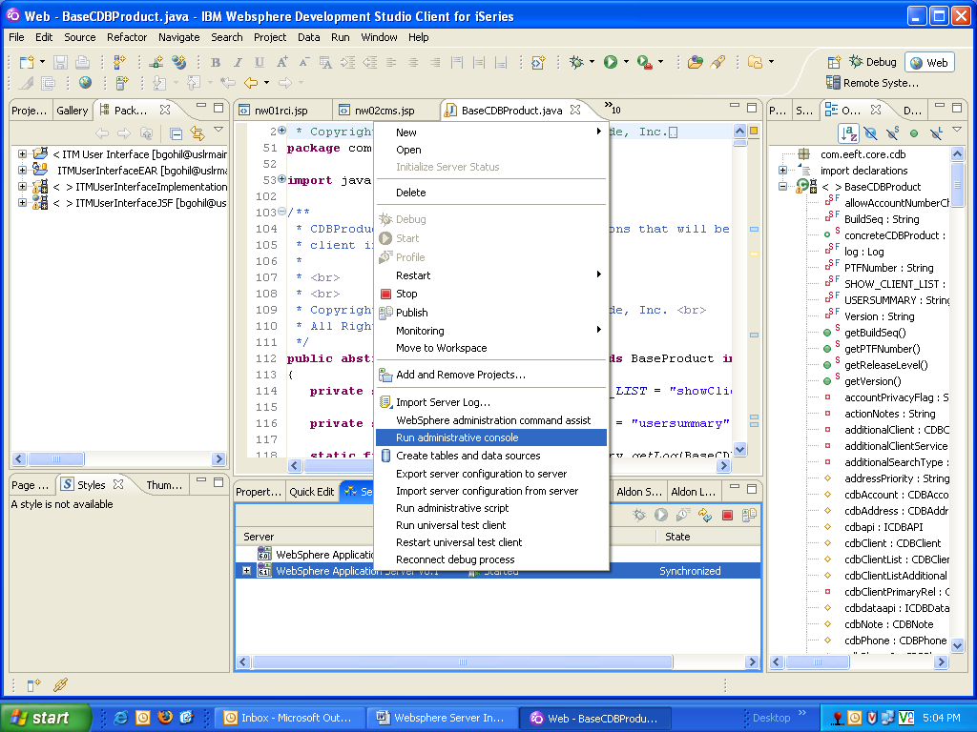
- Select Security in left panel and select Secure administration, applications, and infrastructure
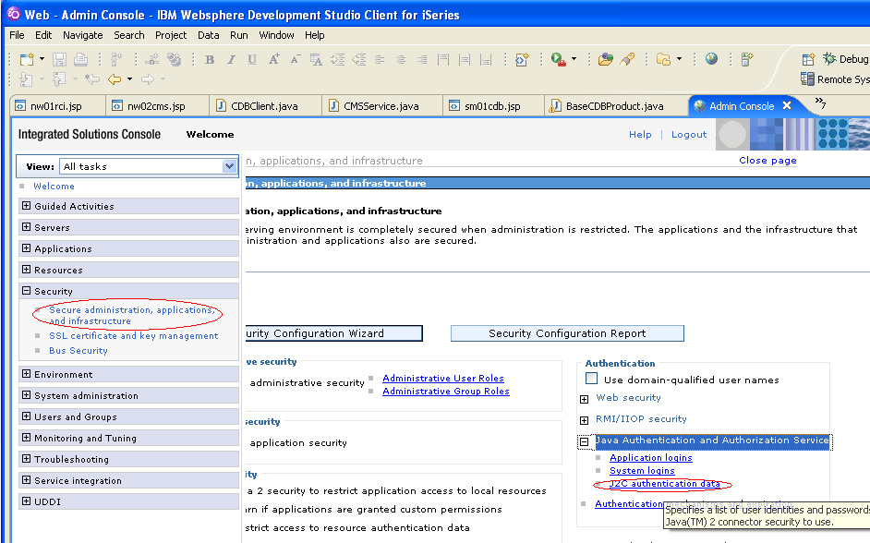
- In Authentication Frame select Java Authentication and Authorization Services. Select J2C Authentication Data.
- it shows following select new
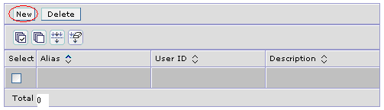

- It shows following screen. Fill following data.

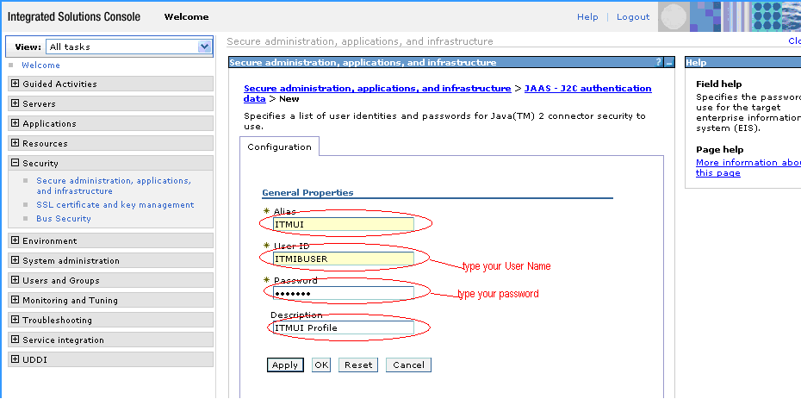

- Press ok. It shows following screen

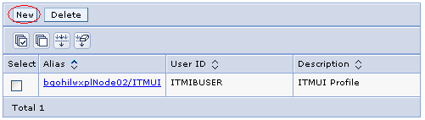
- Select Resources at left panel. Select JDBC Provider in JDBC in same frame and it shows following windows.
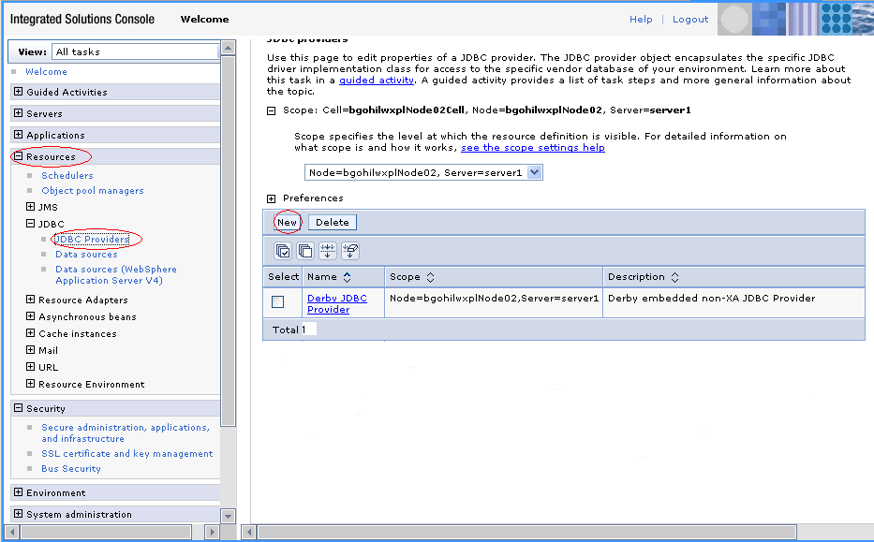

- Select new it shows following windows and fill the following information and click next.

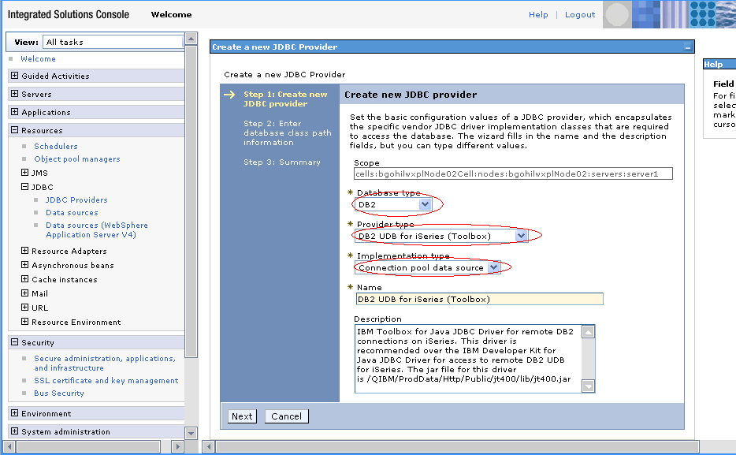
- it shows following screen fill your JT400.jar path like “C:\Program Files\IBM\SDP70Shared\plugins\com.ibm.datatools.db2.iseries_2.0.0.v200610091224\driver\” and select and click next.

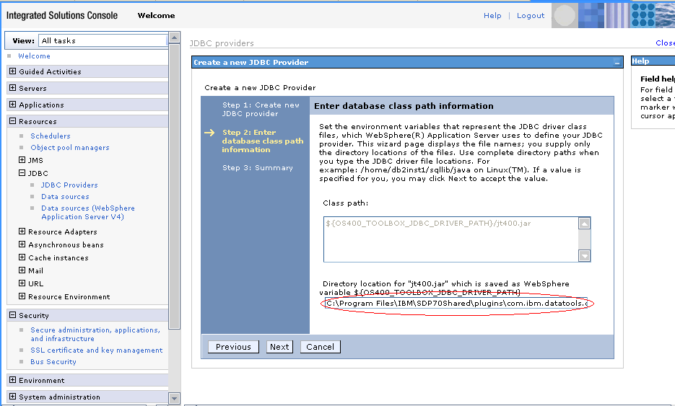
- it shows following screen

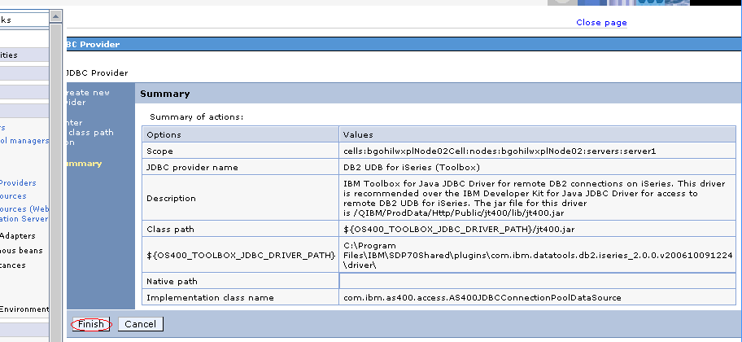
- When you press finish it shows following windows.
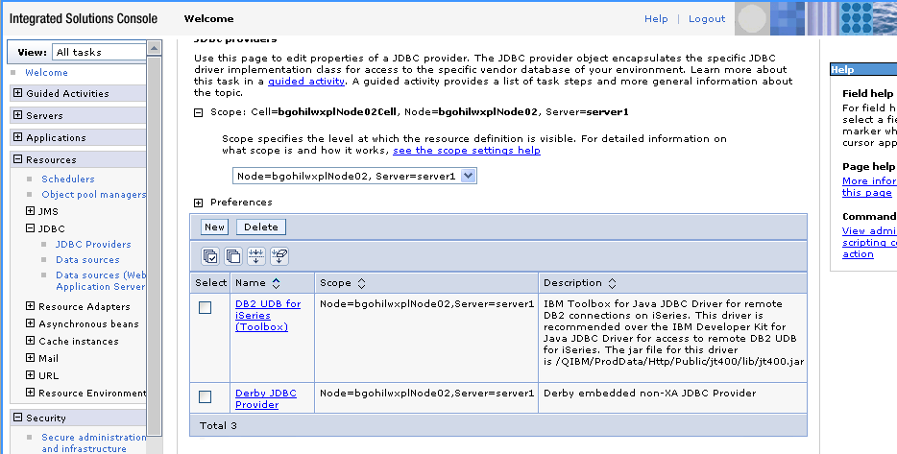

- Select Data Resource in left panel it shows following windows and select new button.

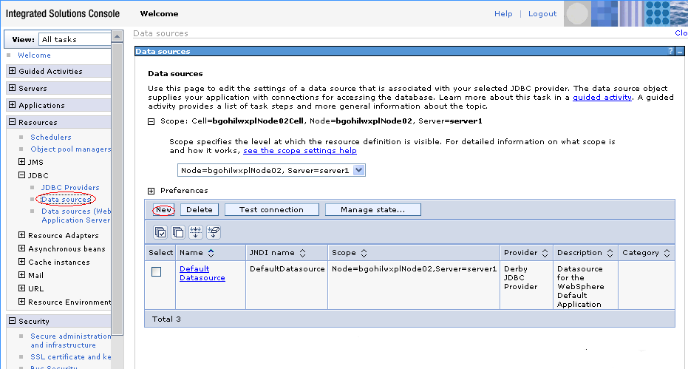

- When you press new it shows following screen and fills the following information and press next.
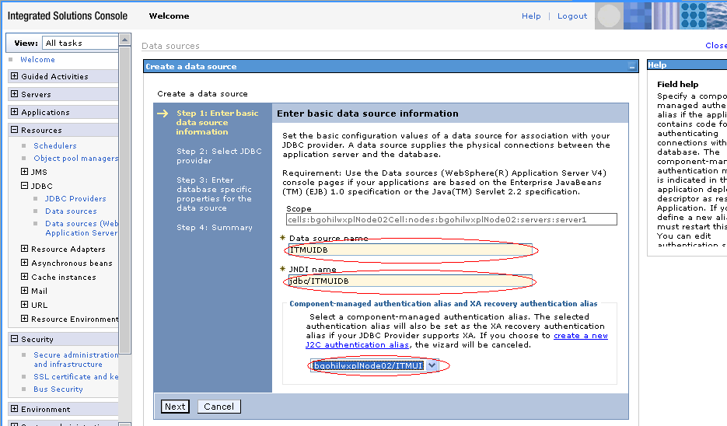

- when you press next it shows following screen. Select existing JDBC provider and select DB2 for iSeries (ToolBox) and press next.

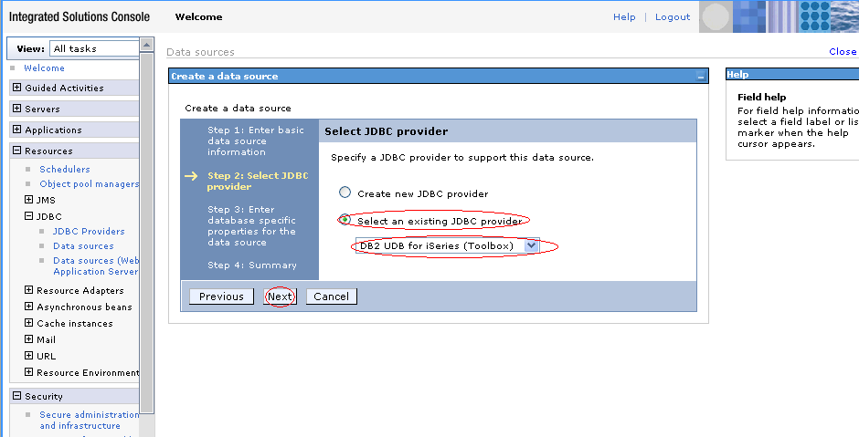
- When you press next then it shows following screen where we have to mention our server name USLRMAIN and press next.

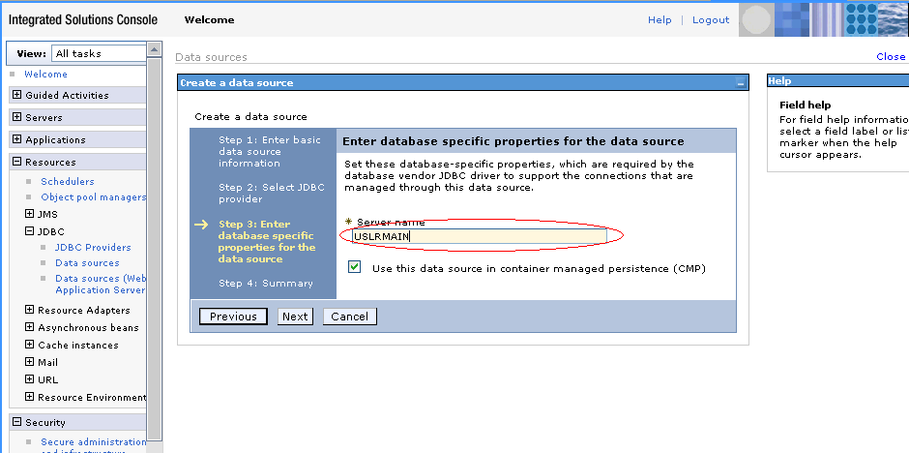
- When you press next it shows following summery screen and then press finish.

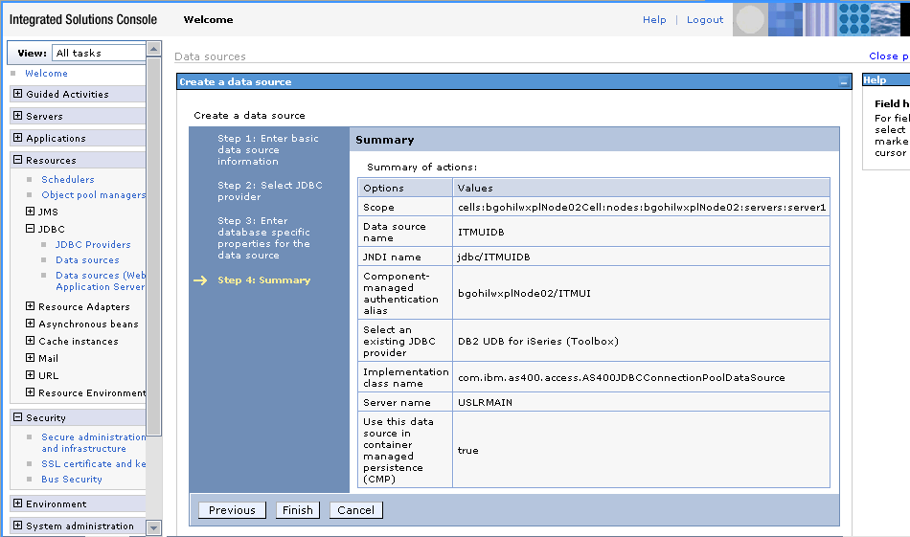
- When you press finish it shows following screen.

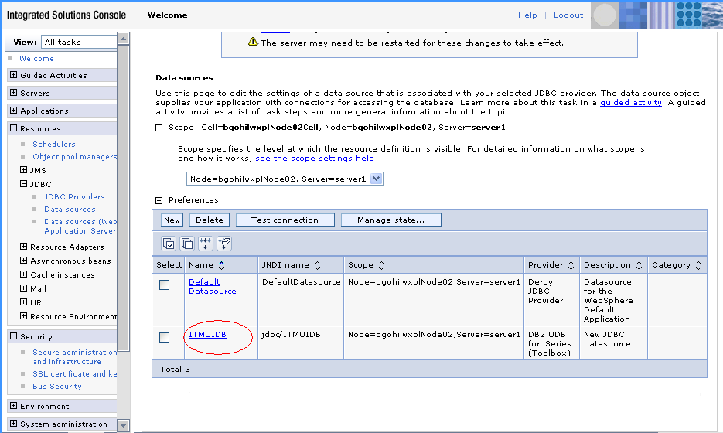

- after completion of this configuration select ITMUIDB it shows following screen

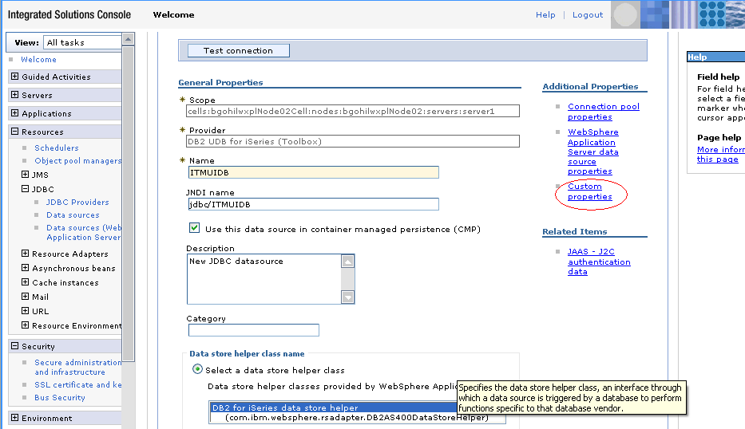
- when you select custom properties it shows following screen

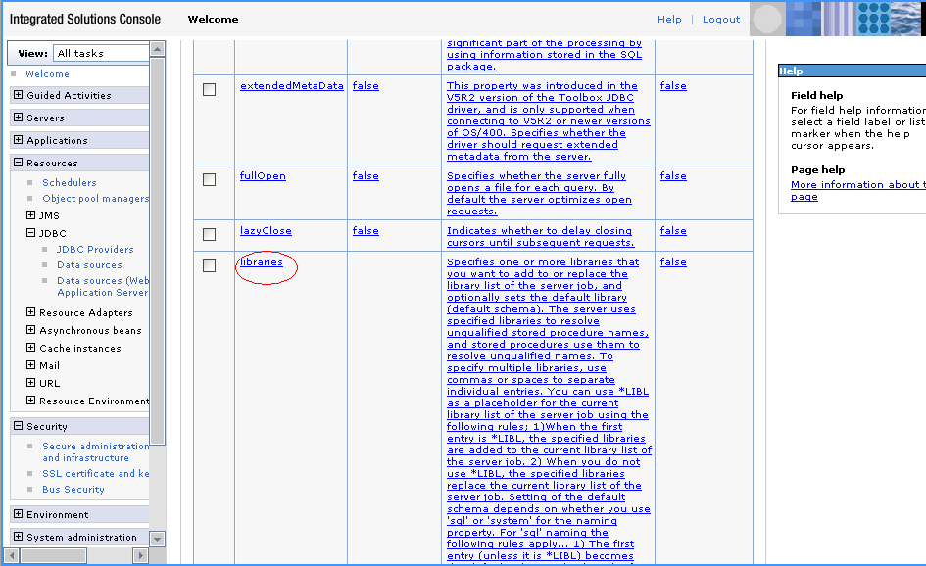
- when you select library, it shows following screen. Fill the following library name
ZZSBYIT310 UIINITNEW ZZSSHIT310 INSTDTALIB ASID0027AR ITMB301 ITMB300 ASIT002729 ASID002729 ASIR002729 ASIB002729 ASIB125901 *LIBL
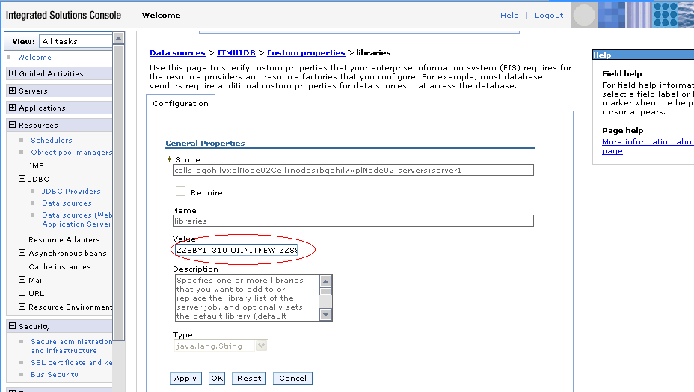
- Press ok
- Now again come to following screen and select data resource and press Test Connection it shows following screen.

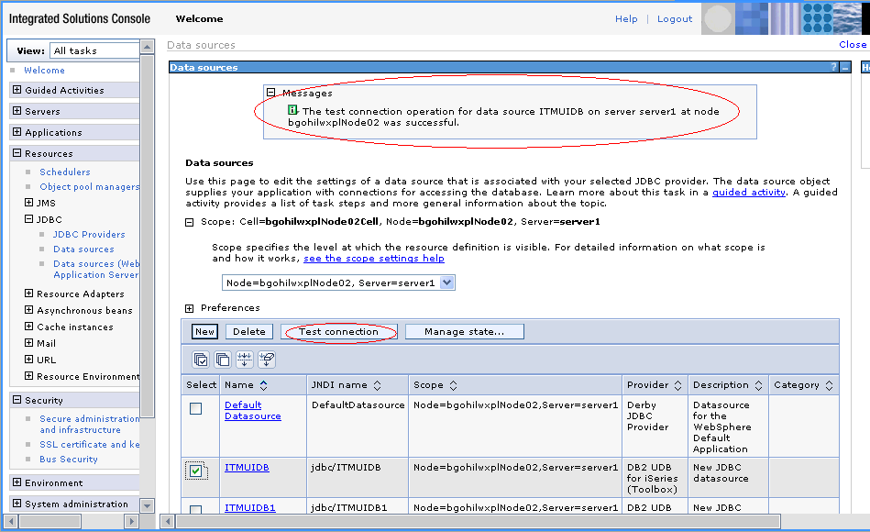
- it shows the message, you connection is successes or not.

